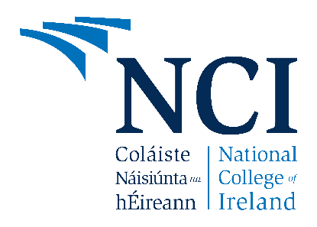

National College of Ireland

Project Proposal
< Title>
<Date>

<Programme Name>
<Specialisation>
<Academic Year i.e. 2020/2021>
<Student Name>
<Student Number>
<Student Email>

Contents
1.0 Objectives 2
2.0 Background 2
3.0 State of the Art 2
4.0 Technical Approach 2
5.0 Technical Details 2
6.0 Special Resources Required 2
7.0 Project Plan 2
8.0 Testing 2

Objectives
(Max half Page)
What does this project set out to achieve?

Background
(Max half Page)
Why did you choose to undertake this project? How will you meet the objectives set out in Section 1.0?

State of the Art
(Max half page)
What similar applications exist already? What makes your project stand out? How does it differ from similar work of others?

Technical Approach
(Max 1 page)
What approach will you take to development? How will you identify requirements? How will you break down requirements into project tasks, activities and milestones?

Technical Details
(Max 1 page)
Implementation language and principal libraries. What are the important algorithms or approaches under consideration for this work?

Special Resources Required
(Max half page)
What special resources if any will be required for this work?

Project Plan
(Max 2 pages)
Project plan with details on implementation steps and timelines. This project plan should provide as much detail as possible for now and will be revised with more detail with the mid point documentation.

Testing
(Max 1 page)
Describe how you will evaluate the system with real technical data using system tests, integration tests etc. If applicable describe how you will evaluate the system with an end user. (be careful here re Ethics etc)

